JUST KEEP SWIMMING
HALLOWEEN PARTY REGISTRATION 2020
Parents/Guardians Full Name:
Participants Full Name:
Phone Number: | E-mail:
Full Address & PC:
DOB: | M/F:
Child’s Diagnosis:
Child’s Medications:
Do we need to administer medication during the day?
Child’s Allergies:
Does your child run, hit, kick, bite or scream? Please circle one: YES NO
Please explain if circled yes above & comment on any other behaviors:

Date of participation: Saturday October 24 OR Saturday, October 31
Ages 6-8 & 8-12 Ages 12-16

10:00AM – 4:00PM
Total: $120.00 + $6.00 gst (0.05%) = $126.00
Payable by: cheque, e-transfer, or cash (please circle)

REGISTRATION: To secure registration, please complete the registration form and e-mail to: justkeepswimmingcalgary@gamil.com To hold your child’s space, payment must be sent as soon as registration is confirmed. Payment can be sent to justkeepswimmingcalgary@gmail.com or to 155 Silver Ridge Close NW, Calgary, AB T3B3T2

I certify that all information provided is correct and I understand that Just Keep Swimming has the right to cancel participation without refund if any of the above information is not completed accurately:
Signature of Parent of Guardian:_______________________________

*Please note, our 1-day events will not be covered by FSCD like summer camps. However, our staff would be more than happy to sign off on respite or community aid hours to assist with funding for participation. Please let us know if you have any questions in regards to this.

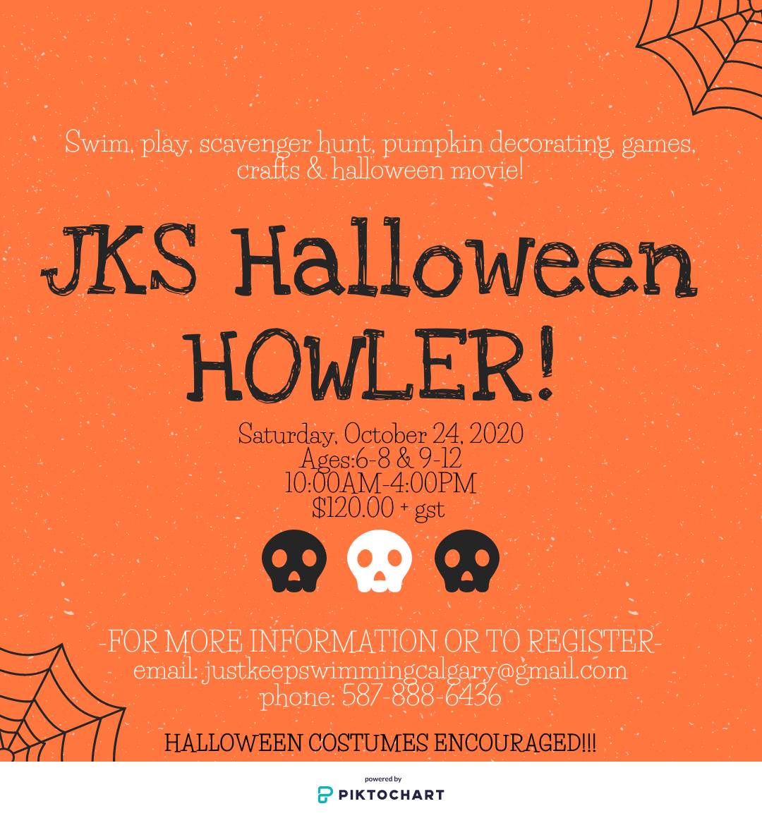

Activities include:
-1 hour to 1.5 hour swimming (depending on group energy lelves)
-Scavenger hunt for treats and toys (all will be sent home none will be eaten at the party).
-Outdoor play and trampoline (weather permitting)
-Indoor Halloween games and activities, including pumpkin decorating
-Halloween movie (approved by all participants families)
Important information:
- Masks are mandatory for all participants and must be worn while inside (not for eating, swimming or outdoor play)
- Participants must bring all food including lunch, snacks and drinks
- swim suit, towel and goggles
- COVID screening 3 hours prior to event. Hand washing and sanitizer stations set up throughout
- Encouraging all participants to come in Halloween costumes
- Maximum 9 participants/ minimum 6
*FSCD COMMUNITY AID OR RESPITE HOURS SIGNING AVAILABLE

